We shall now discuss the trends observed in the form of visualizations that were created in Tableau.

Total Make vs Model (Top-10)

We have several Electric Vehicle manufacturing companies like Tesla, Ford, Nissan, Toyota, etc. We shall see the top 10 auto companies based on the number of vehicles registered.

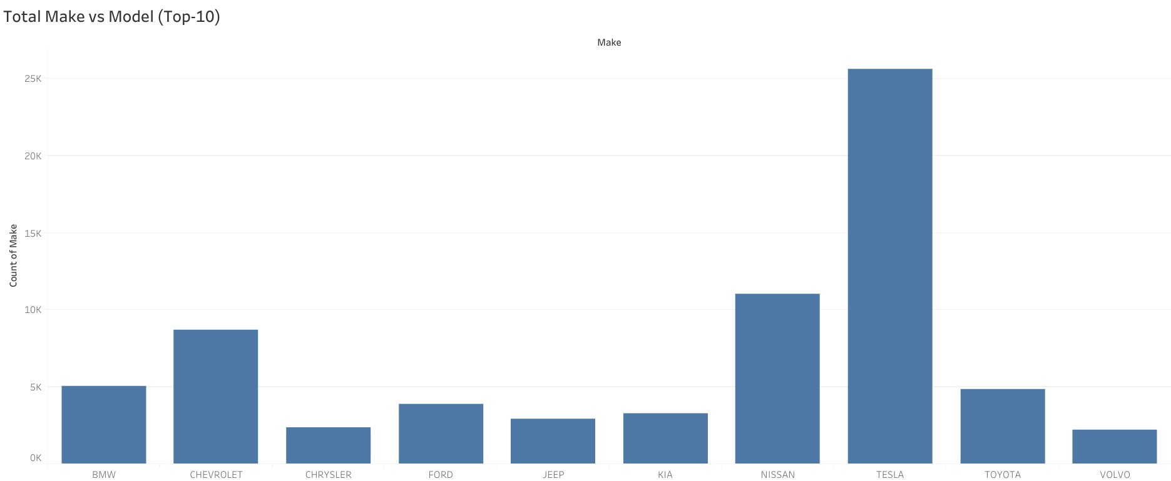

* We see that TESLA has the highest number of EVs registered with 25,601 units manufactured. This a very significant difference when we compare it with NISSAN that has registered the second highest number of EVs with 11,018 units.

EV Population per State

Since the dataset has the EV population in the United States only, let us check the state that has the most number of registered EVs.

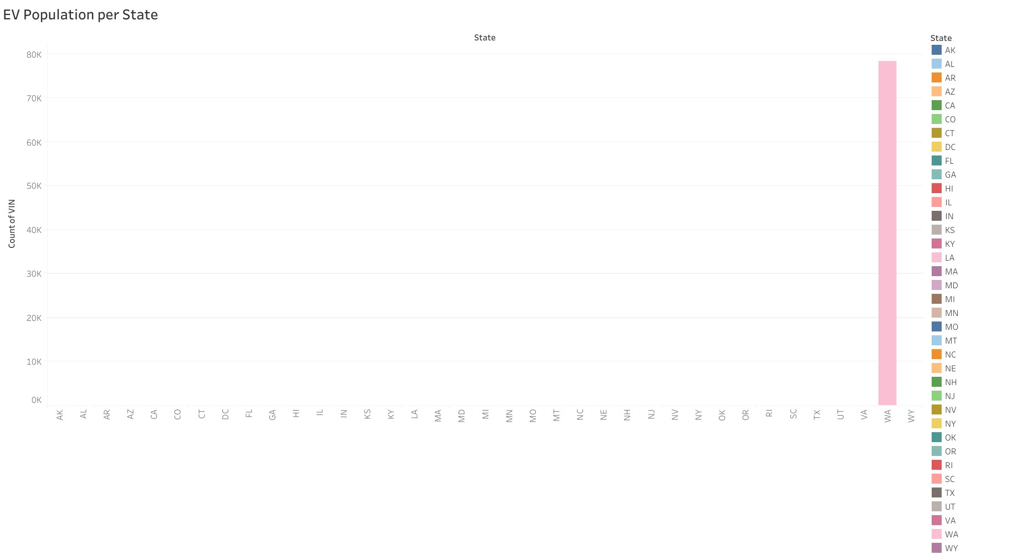

* We see Washington (WA) state has the most number of EVs registered with a phenomenal 78,414 units registered. Other states have barely registered a couple of EVs.
* This could be due to the fact that Washington state has been very proactive in adoption of EVs and is offering exemptions to buyers on EV purchases. Read more at: <https://www.seattletimes.com/business/what-to-know-about-electric-cars-in-washington-state/>

EV Population per Vehicle Type

The dataset has 2 types of electric vehicles namely – Battery Electric Vehicle (BEV) and Plug-In Hybrid Electric Vehicle (PHEV). Battery Electric Vehicle (BEV) type refers to the vehicles that completely run on electrical energy supplied by batteries that are charged when connected to an external power source. Plug-In Hybrid Electric Vehicle (PHEV) is a type of semi-electric vehicle that runs both on electrical energy supplied by batteries that are charged when connected to an external power source and an internal combustion engine that is powered by a carbon fuel or gasoline.

Let us check the proportion of these two electric vehicle types to see which of the 2 has the most number of registered vehicles.

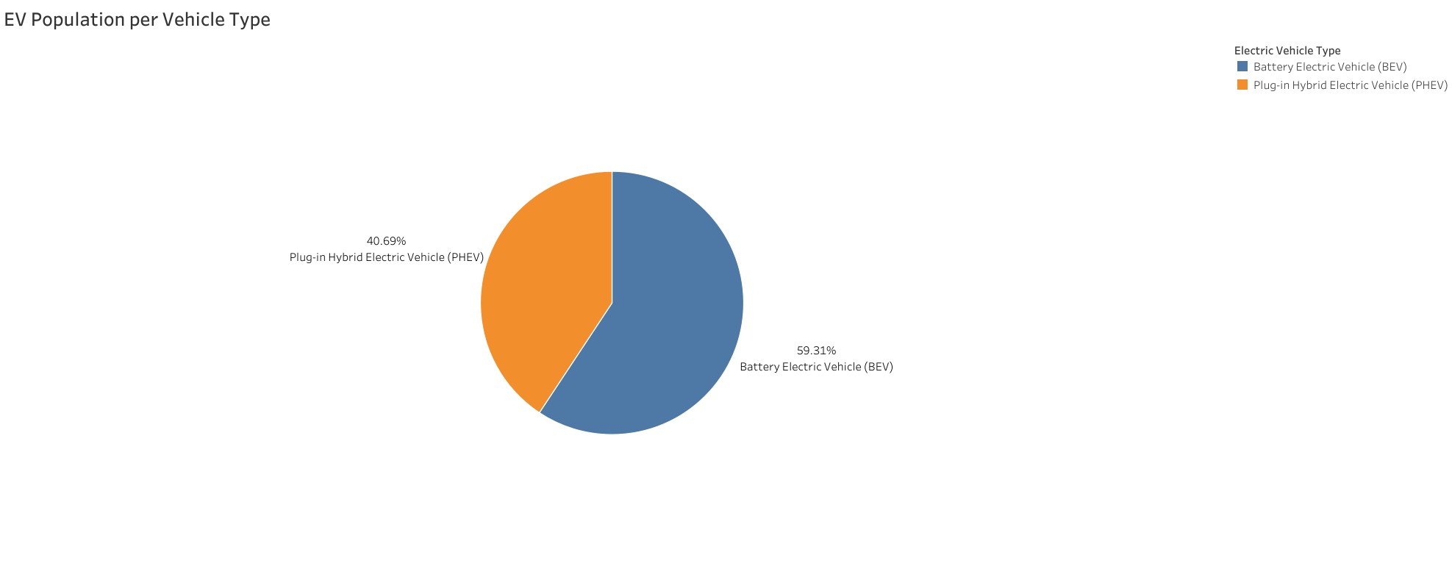

* We see that Battery Electric Vehicles (BEV) type formed most of the electric vehicles registered.
* Given that gasoline costs tend to fluctuate a lot due to several factors, it is natural that people would prefer complete battery-operated vehicles as battery charging is comparatively more economical in the long run than using gasoline as the fuel.

EV Population per Utility

Electric Utility refers to the organisation or legal entity that is involved in the distribution of electrical energy primarily for public utilization. We have a number of such companies that are utilized by users to charge their electric vehicles. Let us check the utility with the most number of users.

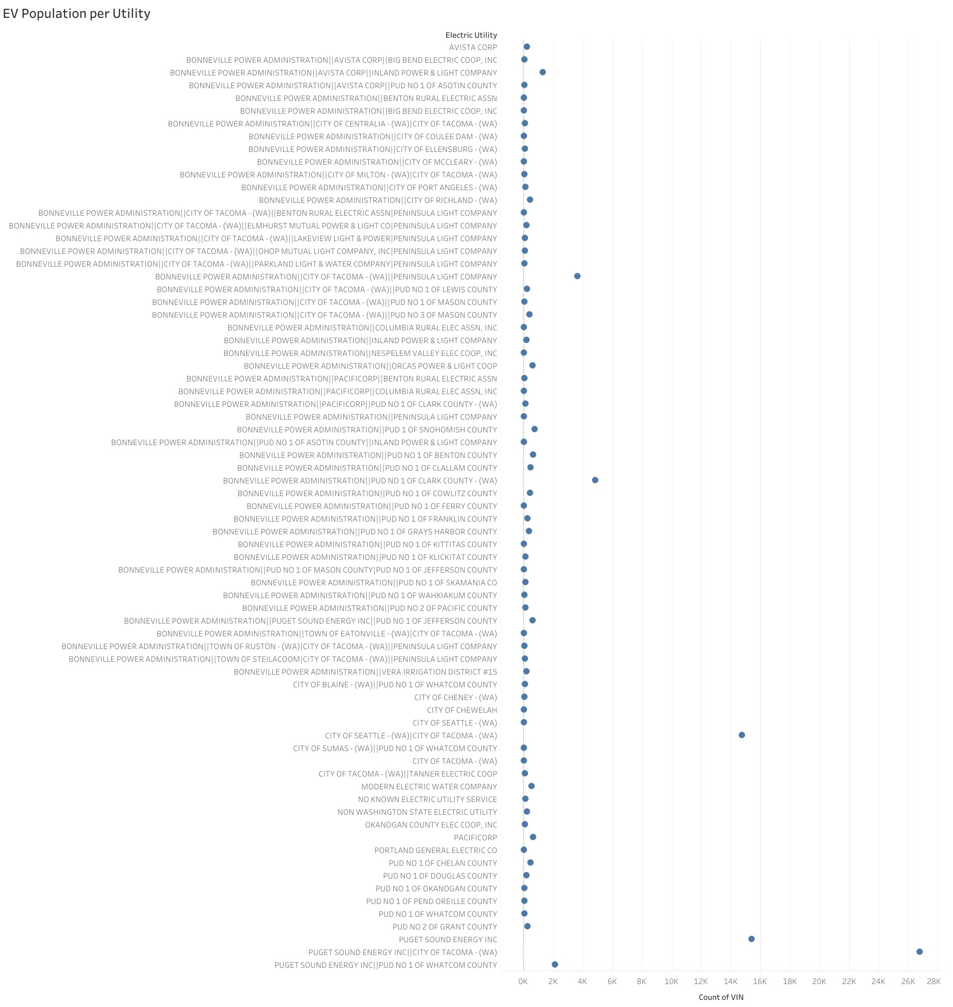

* We see that PUGET SOUND ENERGY INC||CITY OF TACOMA - (WA) has the most number of users with 26,734 users.

EV Population per Location (Geo Plot)

As we have seen above, Washington State (WA) has the highest number of EV users. The same has been depicted below in a Geo Plot showing the map of the United States of America.

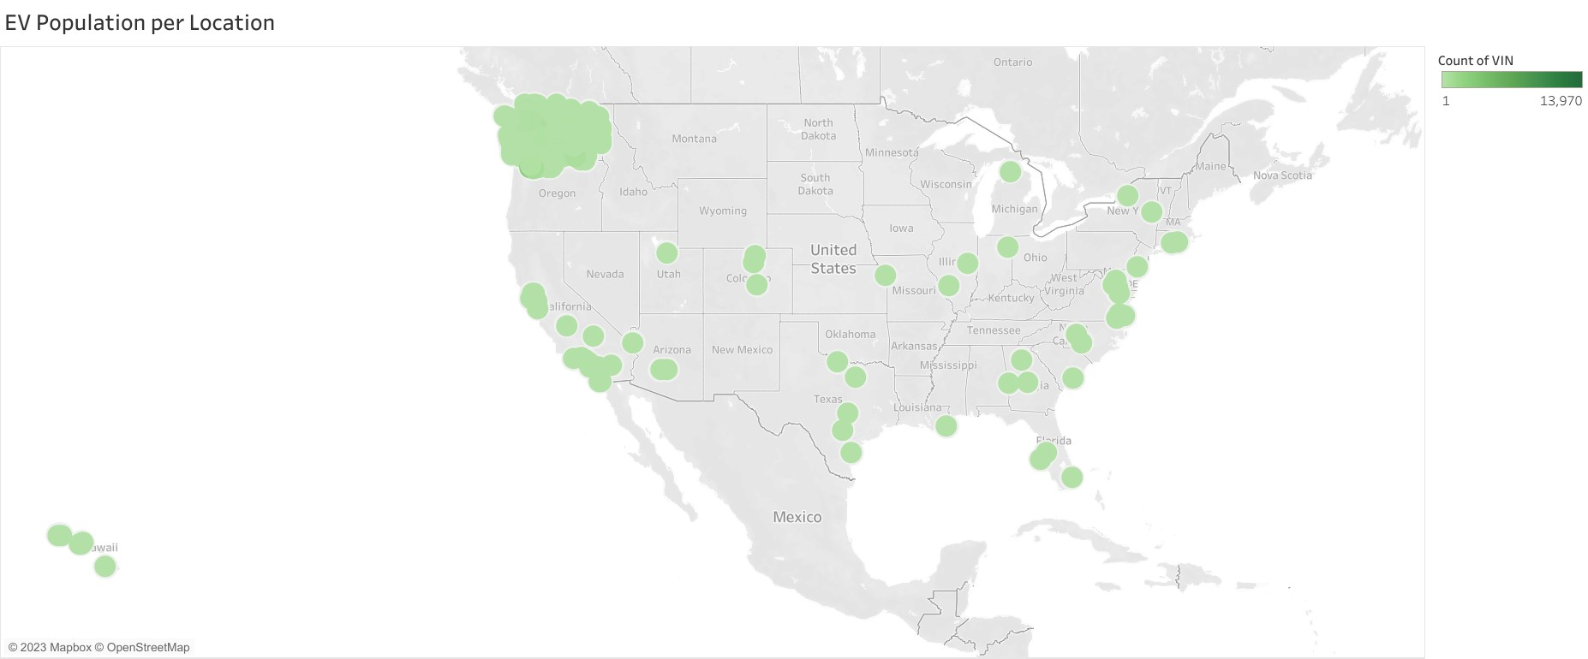

This concludes the final analysis of the project. Given that Washington State has a very high number of electric vehicles users, we see minimal adoption of Electric Vehicles in others states of the USA.

To decrease the carbon footprint, Electric Vehicles are a good starting point which will help in a significant reduction of pollution due to vehicular activities. Other states in the USA need to introduce user-friendly policies such as reduction of sales tax, tie-ups with electric vehicle manufacturers to boost sales and introduce more charging stations, creating awareness in educational institutions regarding the benefits of using electric vehicles, using sustainable sources of electricity generation such as solar energy for power generation, etc.